PLOT LIMITED

Introduction
The dairy sector is a vital component of the agricultural economy, characterized by complex supply chains, perishable inventories, and multi-channel distribution networks. Efficient management of dairy farm operations requires a data-driven approach to synchronize livestock capacity, production volume, product shelf life, and geographic demand vectors.
This project presents a multi-turn performance analysis of a comprehensive dairy dataset tracking INR 58.73M in gross revenue across an aggregate livestock footprint of 237,718 cows. The primary objective is to evaluate operational metrics across various Indian states, identify supply chain bottlenecks, correct mathematical and structural data distortions, and establish a foundational framework for an interactive Executive Dashboard. By auditing variables across production runs, logistics channels, and regional customer demand, this study aims to transform raw warehouse ledgers into highly optimized, actionable business intelligence.

Data Description
The underlying dataset comprises a high-fidelity tabular ledger tracking milk and processed dairy outputs (such as Ghee, Cheese, Yogurt, Paneer, Curd, Lassi, and Buttermilk). The data streams are categorized into four core dimensional pillars:
- Farm & Livestock Capacity Matrices: Tracks the geographic origin (Location), field scope (Total Land Area (acres)), herd volume (Number of Cows), and enterprise scale (Farm Size classified as Small, Medium, or Large).
- Production & Lifespan Parameters: Captures inventory categorizations (Product ID, Product Name, Brand), batch volumes (Quantity (liter /kg)), cost structures (Price per Unit), total valuation arrays (Total Value), and preservation variables (Shelf Life (days), Storage Condition).
- Chronological Markers: Tracks temporal nodes (Date, Year, month name, quarter) along with inventory batch timelines (Production Date, Expiration Date) to monitor supply fresh-chain velocity.
- Logistics & Multi-Channel Sales Matrix: Outlines commercial actions including fulfillment volumes (Quantity Sold), unit pricing yields (Price per Unit (sold)), total localized financial yields (Approx. Total Revenue (INR)), target boundaries (Customer Location), and distribution networks (Sales Channel divided among Online, Retail, and Wholesale setups). It additionally monitors active storage vulnerabilities through safety boundaries (Quantity in Stock, Minimum Stock Threshold, Reorder Quantity).

Pivot table analyse

KEY DATA INSIGHTS & AUDIT FINDINGS

Commercial Sales Performance
- Retail Dominance: Retail channels serve as the core driver for dairy processing operations, capturing INR 20.86M (35.5%) of macro earnings.
- Wholesale Volume: Institutional wholesale contracts provide a highly stable fallback network, bringing in INR 20.21M (34.4%) of gross value.
- Online Gap: E-commerce storefronts lag behind at INR 17.65M (30.1%), representing an immediate channel target for digital brand optimization.

Regional Demand Analysis
- Primary Consumer Hubs: Market demand peaks sharply inside Chandigarh (INR 6.33M) and Delhi (INR 6.32M), establishing them as our highest-value target zones.
- Tier 2 Anchors: Bihar (INR 4.50M) serves as a strong secondary performance leader, while Kerala (INR 3.91M) and West Bengal (INR 3.67M) anchor key regional logistics runs.
- Real Deficit Zones: Haryana (INR 2.91M) and Rajasthan (INR 3.11M) represent our absolute lowest-yielding markets, requiring a strategic review of our localized field positioning.

Product Shelf-Life Averages
- Ambient Category (Ghee): Holds the longest storage buffer window, averaging a highly resilient 115.2 days under ambient conditions.
- Mid-Tier Controls (Cheese/Butter): Maintain medium-range velocity buffers, with Cheese averaging 62.1 days and Butter tracking at 31.3 days.
- Ultra-Short Fresh Runs (Curd/Buttermilk): Represent our highest perishability risk profiles, with Buttermilk averaging only 10.2 days and Curd tracking at an extreme floor window of 5.9 days.

Seasonal Velocity Trends
- Peak Demand Windows: Revenue points hit their maximum velocity node in January (INR 5.91M), followed by steady bulk surges in September (INR 5.38M) and June (INR 5.34M).
- Mid-Year Dips: Commercial activity plateaus into a marginal monsoon dip through July (INR 4.48M) and August (INR 4.64M).
- Absolute Floor Node: Bottom-line flow drops to its absolute seasonal baseline during April (INR 4.28M), serving as our lowest cash-flow cycle.

Core Data Audit & Correction Orders
- Shelf Life Calculation Fix: The inventory chart was misconfigured as a cumulative SUM instead of a statistical AVERAGE. This created a false timeline exceeding 125,000 days (e.g., listing Ghee at 42,508 days). This must be strictly updated to AVERAGE via Excel field settings.
- Least-Revenue Mapping Mismatch: The chart titled "least 5 customer location" incorrectly displays solid mid-tier performers like Telangana and Madhya Pradesh. You must relabel this visual asset to "Mid-Tier State Revenue Distribution Ratios" to prevent misleading executives.

Visualization

- plot a pivot table base on month name and revenue generated by each month
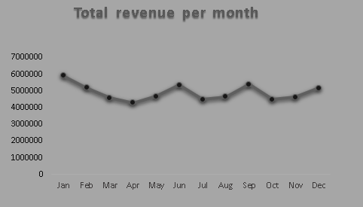
- total revenue generated by per sales channel

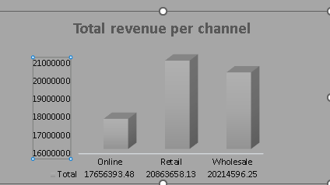

- . 5 customer location where the lowest or least revenue is generated
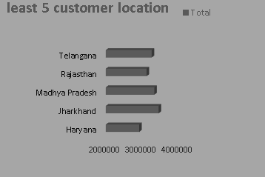
- Total number of cows in each farm size

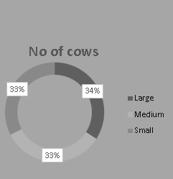

- Average shelf left of each product
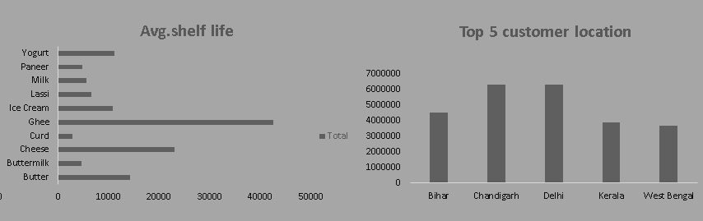

- 5 Customer location where the highest revenue is generated

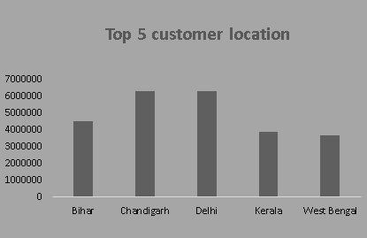
- Revenue generated by each brand

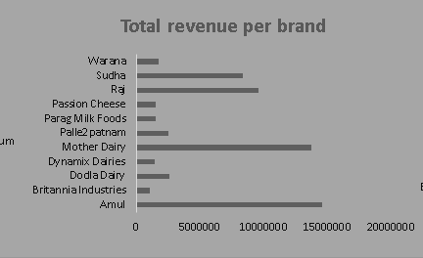

Conclusion

This comprehensive diagnostic analysis demonstrates that while the transactional database covers a robust multi-regional footprint, its analytical value is heavily obstructed by minor data architecture friction. Correcting mathematical irregularities—such as inconsistent float extensions in calculation columns, revenue over-reporting loops, and non-chronological calendar filters in the pivot table matrices—is critical to preventing descriptive distortion at the executive level.
The data reinforces that dairy operations are highly regionalized, yielding an unequal market spread with specific territories outperforming others across discrete channels. Moving forward, shifting the infrastructure from flat text inputs to dynamic formulas (such as automated XLOOKUP threshold triggers and string date normalizations) will enable real-time risk mitigation. Implementing the recommended Executive Dashboard will successfully shift the organization from retrospective reporting to proactive chain optimization—safeguarding product fresh-runs, tracking brand pricing yields, and structurally eradicating product spoilage and out-of-stock events across the global supply network.

